**LAB Cycle sheet – 2**

**Internet and Web Programming**

**CSE3002**

**L55+L56**

**19BCE2141**

**Q1.**

**Code (HTML and JavaScript) –**

<!DOCTYPE html>

<html lang="en">

<head>

<meta charset="UTF-8">

<meta http-equiv="X-UA-Compatible" content="IE=edge">

<meta name="viewport" content="width=device-width, initial-scale=1.0">

<title>Q1</title>

<script>

var num1=prompt("Enter the first number: ","0");

var num2=prompt("Enter the second number: ","0");

var num3=prompt("Enter the third number: ","0");

var max=0;

num1=parseInt(num1);

num2=parseInt(num2);

num3=parseInt(num3);

if(num1>num2 && num1>num3)

{

max=num1;

}

else if (num2>num1 && num2>num3)

{

max=num2;

}

else

{

max=num3;

}

</script>

</head>

<body>

<h1 id="display"></h1>

<script>

document.getElementById("display").innerHTML = "The maximum is" +max;

</script>

</body>

</html>

**Output –**

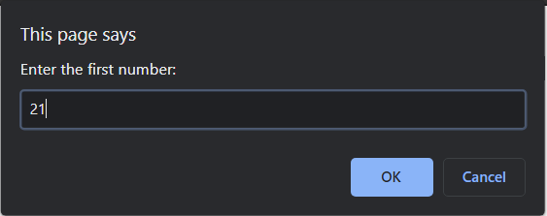

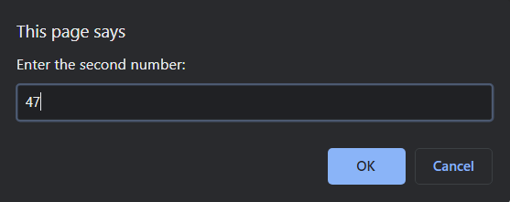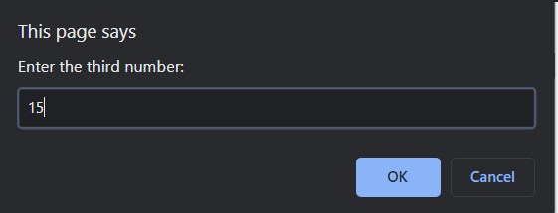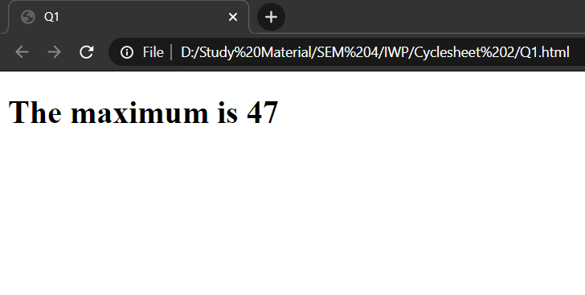

**Q2.**

**Code (HTML and JavaScript) –**

<!DOCTYPE html>

<html lang="en">

<head>

<meta charset="UTF-8">

<meta http-equiv="X-UA-Compatible" content="IE=edge">

<meta name="viewport" content="width=device-width, initial-scale=1.0">

<title>Q2</title>

<script>

function count(arr,n) {

var c=0;

for(var i=0;i<n;i++)

{

if(arr[i]>13 && arr[i]<29)

c++;

}

return c;

}

</script>

</head>

<body>

<h1 id="display"></h1>

<script>

var arr = [21,16,5,9,14,45,40,24,18,60];

var n=10;

var c = count(arr,n);

document.getElementById("display").innerHTML = "The number of items in the array that is greater than 13 and less than 29 are " +c;

</script>

</body>

</html>

**Output –**

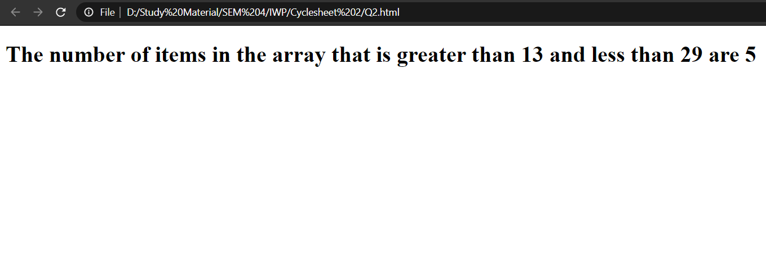

**Q3.**

**Code(HTML AND JavaScript) –**

<!DOCTYPE html>

<html lang="en">

<head>

<meta charset="UTF-8">

<meta http-equiv="X-UA-Compatible" content="IE=edge">

<meta name="viewport" content="width=device-width, initial-scale=1.0">

<title>Q3</title>

<script>

var miles = prompt("Enter the number of miles: ","0");

var cost = prompt("Enter the cost of a gallon: ","0");

var consumption = prompt("Enter the consumption: ","0");

miles = parseFloat(miles);

cost = parseFloat(cost);

consumption = parseFloat(consumption);

var total = (miles/consumption) * cost;

document.writeln("<h1>The total cost is Rs "+total+"</h1>");

</script>

</head>

<body>

</body>

</html>

**Output –**

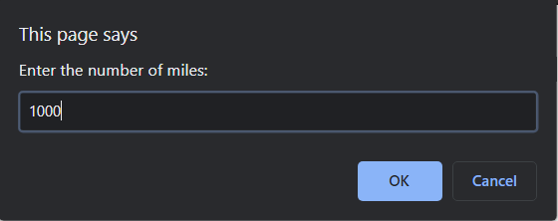 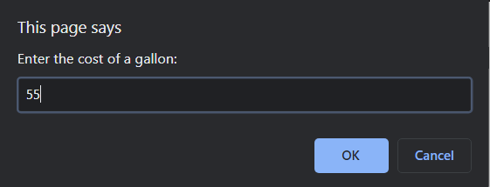 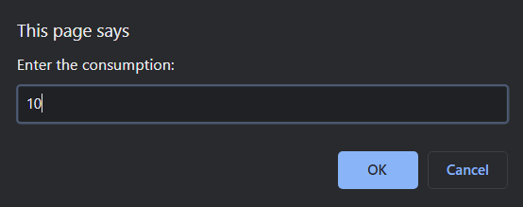 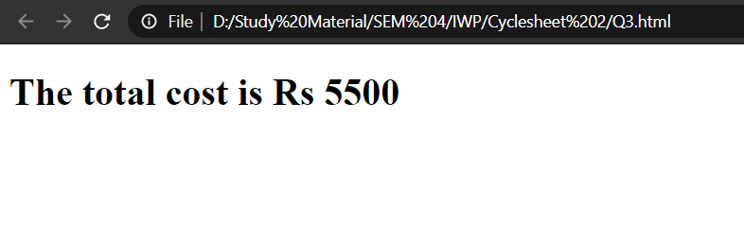

**Q4.**

**Code(HTML and JavaScript) –**

<!DOCTYPE html>

<html lang="en">

<head>

<meta charset="UTF-8">

<meta http-equiv="X-UA-Compatible" content="IE=edge">

<meta name="viewport" content="width=device-width, initial-scale=1.0">

<title>Q4</title>

<script>

function happy_number(num) {

var m, n

var c = []

while (num != 1 && c[num] !== true) {

c[num] = true

m = 0

while (num > 0) {

n = num % 10

m += n * n

num = (num - n) / 10

}

num = m

}

return num == 1

}

var cnt = 5

var num = 1

var f5 = ''

while (cnt-- > 0) {

while (!happy_number(num)) num++

f5 = f5 + (num + ' ')

num++

}

document.writeln('<h1>First 5 happy numbers are : ' + f5 +'</h1')

</script>

</head>

<body>

</body>

</html>

**Output –**

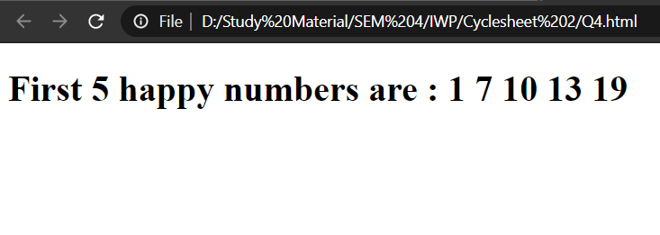

**Q5.**

**Code –**

**HTML**

<!DOCTYPE html>

<html lang="en">

<head>

<meta charset="UTF-8">

<meta http-equiv="X-UA-Compatible" content="IE=edge">

<meta name="viewport" content="width=device-width, initial-scale=1.0">

<title>Q5</title>

<link rel="stylesheet" href="Q5.css">

<script src="Q5.js"></script>

</head>

<body>

<h1 class="center">Greeting Card</h1><br>

<div class="center">

<div class="card" id="bimg">

<form>

<input type="text" placeholder="Insert Heading Here" class="heading">

<br><br><br>

<div id="imgContainer">

<img id="cardImage" height="150" src="https://upload.wikimedia.org/wikipedia/commons/thumb/e/ec/Happy_smiley_face.png/480px-Happy_smiley_face.png">

</div>

<br><br><br>

<textarea cols="60" rows="13" placeholder="Enter the body of the greeting card here" class="body" id="btext"></textarea>

</form>

</div>

</div>

<br>

<span class="option">Choose a background image:</span>

<br><br>

<div class="flex">

<img src="https://img.freepik.com/free-photo/hand-painted-watercolor-background-with-sky-clouds-shape_24972-1095.jpg?size=626&ext=jpg" onclick="upDate_img(this)">

<img src="https://img.rawpixel.com/s3fs-private/rawpixel_images/website_content/p-448-pai-208.jpg?w=800&dpr=1&fit=default&crop=default&q=65&vib=3&con=3&usm=15&bg=F4F4F3&ixlib=js-2.2.1&s=10bba5369035df0f4e89fab0de99b572" onclick="upDate_img(this)">

<img src="https://img.rawpixel.com/s3fs-private/rawpixel_images/website_content/v546batch3-mynt-34-badgewatercolor_1.jpg?w=800&dpr=1&fit=default&crop=default&q=65&vib=3&con=3&usm=15&bg=F4F4F3&ixlib=js-2.2.1&s=89288ef4b47127f7f34a5998b50e4470" onclick="upDate_img(this)">

</div>

<br>

<span class="option">Choose position of the image: </span>

<br><br>

<div class="flex">

<span class="color-options" style="padding: 10px 20px;" onclick="changePosition('left')">left</span>

<span class="color-options" style="padding: 10px 20px;" onclick="changePosition('center')">center</span>

<span class="color-options" style="padding: 10px 20px;" onclick="changePosition('right')">right</span>

</div>

<br>

<span class="option">Choose a font size for the body:</span>

<br><br>

<div class="flex">

<span class="color-options" style="font-size: 14px; padding: 10px 20px;" onclick="upDate_size(14)">14px </span>

<span class="color-options" style="font-size: 16px; padding: 10px 20px;" onclick="upDate_size(16)">16px </span>

<span class="color-options" style="font-size: 18px; padding: 10px 20px;" onclick="upDate_size(18)">18px</span>

</div>

<br>

<span class="option">Choose a font color for the body:</span>

<br><br>

<div class="flex">

<span class="color-options" style="color: blue; padding: 10px 20px;" onclick="upDate_color('blue')">Blue </span>

<span class="color-options" style="color: red; padding: 10px 20px;" onclick="upDate_color('red')">Red </span>

<span class="color-options" style="color: black; padding: 10px 20px;" onclick="upDate_color('black')">Black</span>

</div>

</body>

</html>

**CSS**

.center {

text-align: center;

}

.card {

border: black solid medium;

display: inline-block;

text-align: center;

background-image: url(https://img.freepik.com/free-photo/hand-painted-watercolor-background-with-sky-clouds-shape_24972-1095.jpg?size=626&ext=jpg);

padding: 20px;

background-size: 592px 592px;

}

.heading {

border: none;

background: none;

font-size: 24px;

text-align: center;

font-weight: 600;

}

.body {

border: none;

background: none;

font-size: 18px;

font-family: Arial, Helvetica, sans-serif;

}

.option {

font-size: 20px;

font-weight: bold;

margin-left: 10px;

}

.flex {

display: flex;

}

.flex img {

width: 200px;

height: 200px;

margin: 0px 10px;

border: black 2px solid;

}

#imgContainer {

display: flex;

width: 100%;

}

#cardImage {

display: block;

}

.flex img:hover{

cursor: pointer;

}

.color-options:hover{

cursor: pointer;

}

.heading:focus{

outline: none;

}

.body:focus{

outline: none;

}

**JavaScript**

function upDate_img(img) {

var x = document.getElementById('bimg')

x.style.backgroundImage = 'url(' + img.src + ')'

}

function upDate_color(color) {

var x = document.getElementById('btext')

x.style.color = color

}

function upDate_size(num) {

var x = document.getElementById('btext')

x.style.fontSize = num + 'px'

}

function changePosition(position) {

var x = document.getElementById('imgContainer')

if (position == 'left') {

x.style.justifyContent = 'flex-start'

} else if (position == 'right') {

x.style.justifyContent = 'flex-end'

} else {

x.style.justifyContent = 'center'

}

}

**Output –**

**Initially**

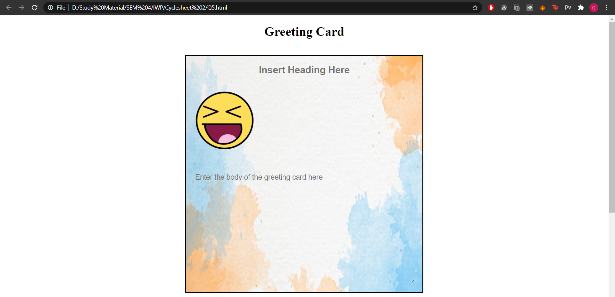

**Options**

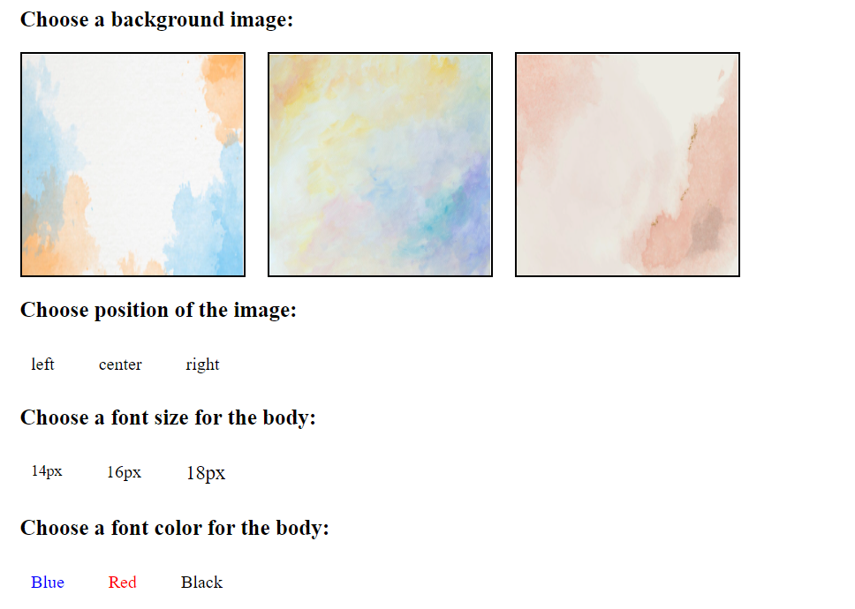

**After changing some options**

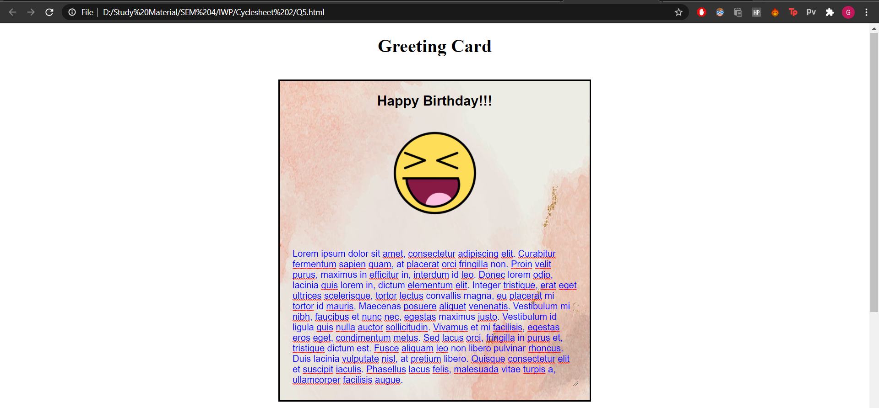

**Q6.**

**Code(HTML and JavaScript) –**

<!DOCTYPE html>

<html lang="en">

<head>

<meta charset="UTF-8">

<meta http-equiv="X-UA-Compatible" content="IE=edge">

<meta name="viewport" content="width=device-width, initial-scale=1.0">

<title>Q6</title>

</head>

<body>

<form>

<h1>

<label for="hours">Enter the number of hours: </label>

<input type="text" id="hours" name="hours" value="0">

<button type="button" value="submit" onclick="calculate_Charges()">Submit</button>

</h1>

</form>

<h1 id="display"></h1>

<script>

var total = 0.0;

var sum = 0.0;

function calculate_Charges()

{

sum=0.0;

var x = document.getElementById("hours").value;

if(x<=3 && x>0)

sum = 2.0;

else{

sum = 2.0

for(var i=4;i<=x;i++)

sum = sum + 0.5;

}

if(sum>10)

sum=10;

total = total + sum;

document.getElementById("display").innerHTML = "The charge for the customer: $"+ sum +"<br>The running total of yesterday's receipt: $"+ total;

}

</script>

</body>

</html>

**Output –**

**Initially**

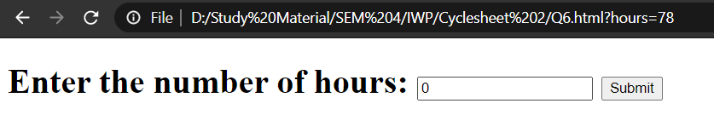

**After entering one value**

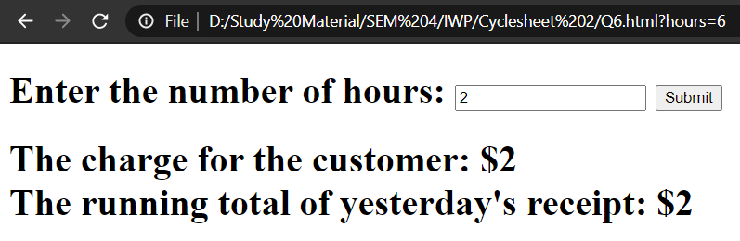

**After entering multiple values**

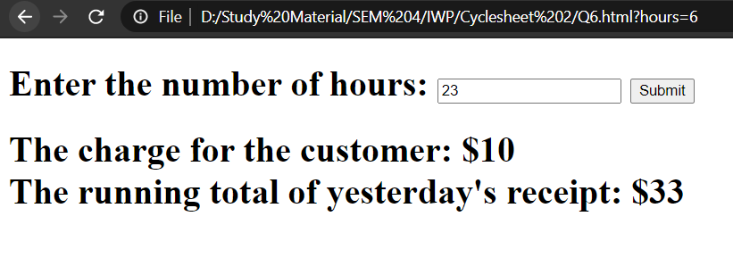

**Q7.**

**Code –**

**HTML**

<!DOCTYPE html>

<html lang="en">

<head>

<meta charset="UTF-8">

<meta http-equiv="X-UA-Compatible" content="IE=edge">

<meta name="viewport" content="width=device-width, initial-scale=1.0">

<title>Q7</title>

<link rel="stylesheet" href="Q7.css">

<script src="Q7.js"></script>

</head>

<body onload="load()">

<div class="box">

<span class="word" id="word"></span><br>

<span class="hint" id="hint"></span>

<form><input type="text" name="answer" id="answer" class="answer" placeholder="Enter your answer"></form><br>

<button class="check" id="check" onclick="button_click()">CHECK ANSWER</button><br>

</div>

</body>

</html>

**CSS**

body{

padding: 20px;

}

.box{

border: solid black 2px;

background-color: rgb(196, 193, 193);

margin: 100px auto;

width: 50%;

height: 250px;

text-align: center;

padding: 20px;

box-shadow: 0 12px 16px 0 rgba(0,0,0,0.24), 0 17px 50px 0 rgba(0,0,0,0.19);

}

.word{

display: inline-block;

color: red;

font-size: 72px;

}

.answer{

margin-top: 10px;

font-size: 18px;

border: none;

background-color: gray;

color: white;

padding: 5px;

text-align: center;

}

.check{

font-size: 16px;

padding: 10px;

background-color: rgb(2, 197, 2);

border-radius: 20px;

color: white;

margin-top: 0px;

border: solid 2px black;

}

.hint{

color: rgb(2, 143, 2);

font-size: 32px;

}

.answer:focus{

outline: none;

}

.check:hover{

background-color: rgb(2, 155, 2);

}

.check:active{

background-color: rgb(1, 119, 1);

}

.check:focus{

outline: none;

}

::placeholder{

color: white;

opacity: 0.7;

}

**JavaScript**

var ques = ["PPLEA","PLTOAP","ECPMORTU","BSMERLCA","EBKODARY"];

var ans = ["APPLE","LAPTOP","COMPUTER","SCRAMBLE","KEYBOARD"];

var hint = ["An _______ a day, keeps the doctor away","A portable device on which you can play this game","A non-portable device on which you can play this game","Name of this game","The device you are using to write your answers"];

var c=0;

var i=0;

var x="";

var s=0;

function load(){

i=Math.floor(Math.random()*5);

document.getElementById("word").innerHTML = ques[i];

document.getElementById("hint").innerHTML = hint[i];

}

function button_click(){

x = document.getElementById("answer").value;

if(ques[i]!="done" && c!=5)

{

ques[i]="done";

x=x.toUpperCase();

if(x==ans[i]){

alert("Success");

s++;

}

else

alert("Wrong Answer");

c++;

}

i = Math.floor(Math.random()*5);

while(ques[i]=="done" && c!=5)

{

i=Math.floor(Math.random()*5);

}

if(c!=5)

{

document.getElementById("word").innerHTML = ques[i];

document.getElementById("hint").innerHTML = hint[i];

}

else

{

document.getElementById("word").innerHTML = "QUIZ COMPLETE";

document.getElementById("hint").innerHTML = "Your Score is: "+s;

document.getElementById("answer").style.display="none";

document.getElementById("check").style.display="none";

}

document.getElementById("answer").value = "";

}

**Output –**

**Initially**

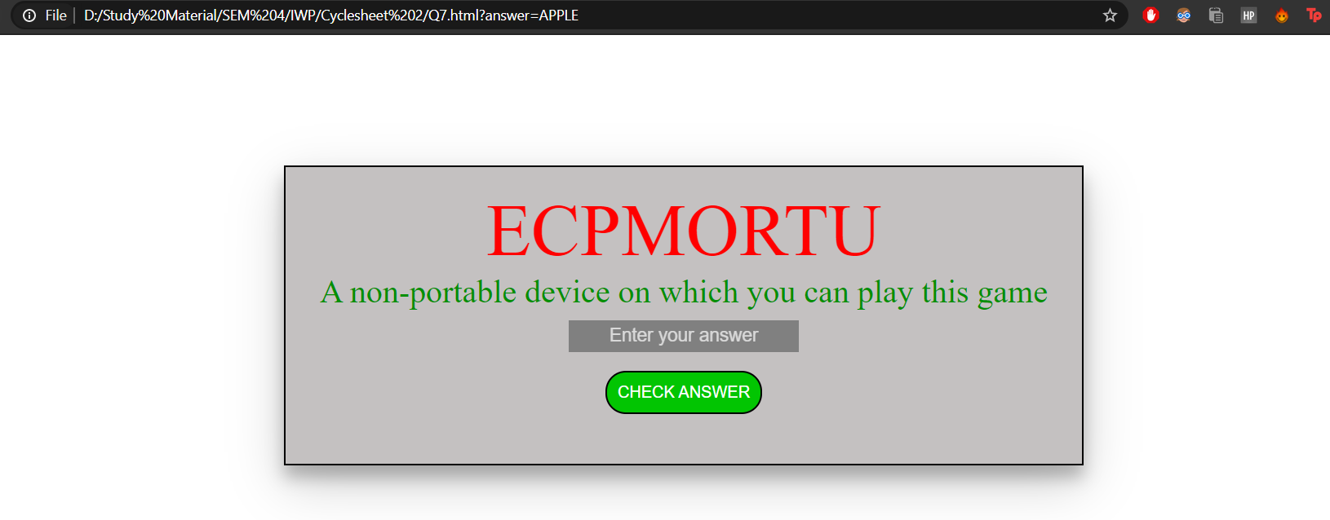

**After 1st word**

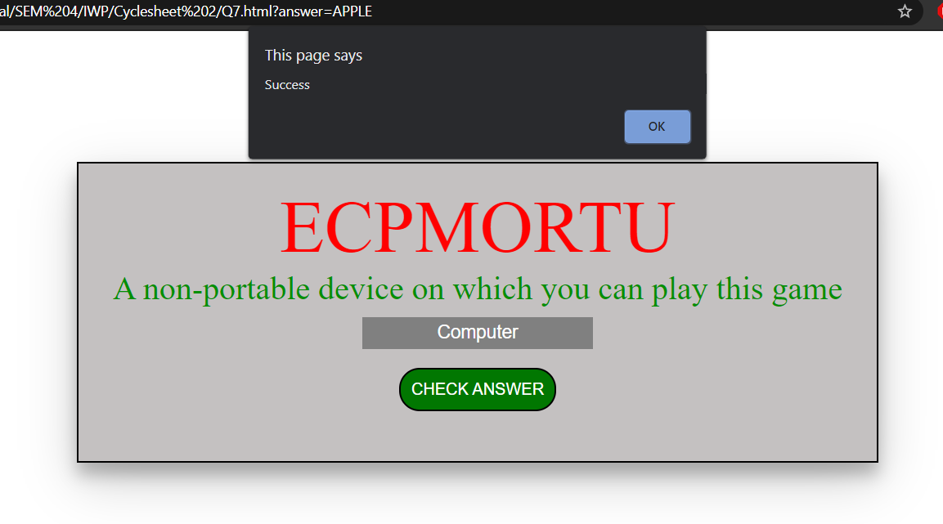

**After 2nd word**

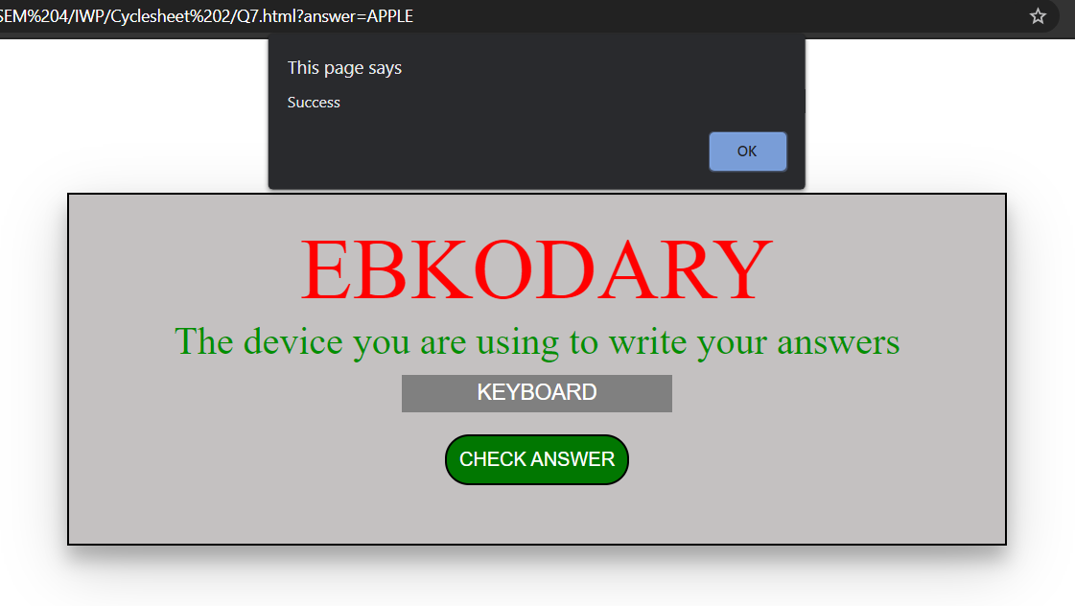

**After 3rd word**

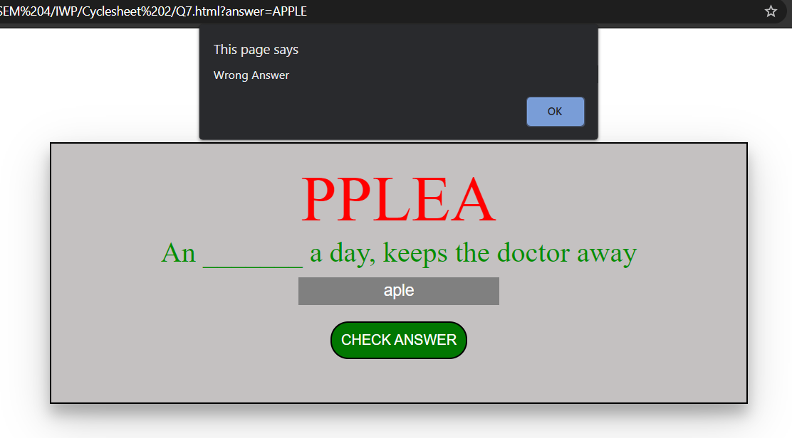

**After 4th word**

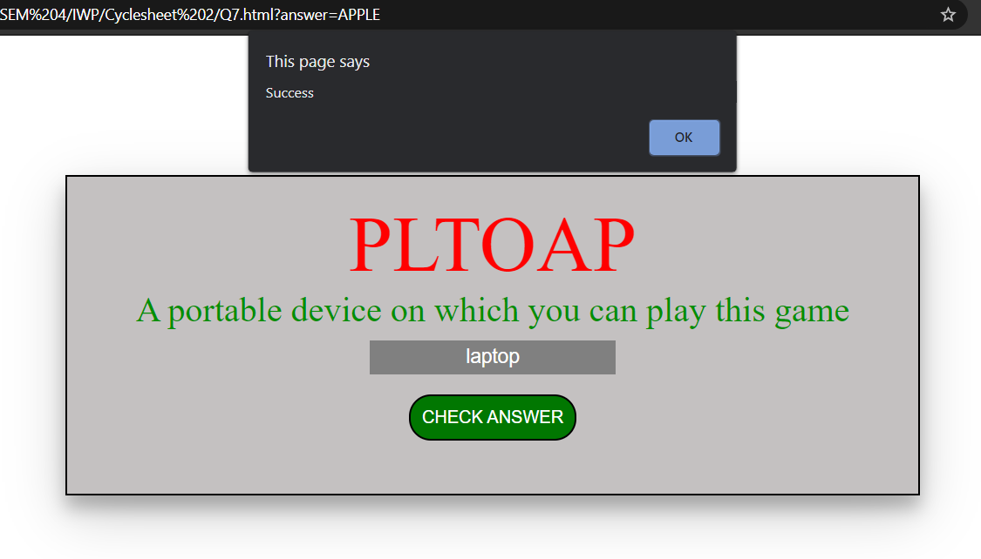

**After 5th(last) word**

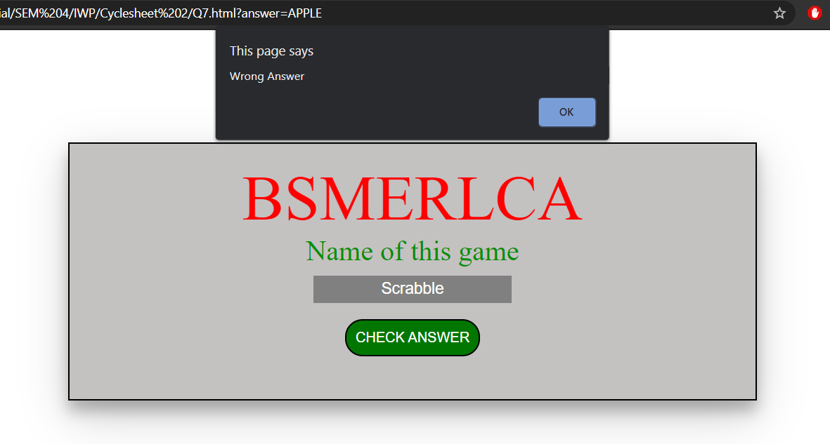

**Result**

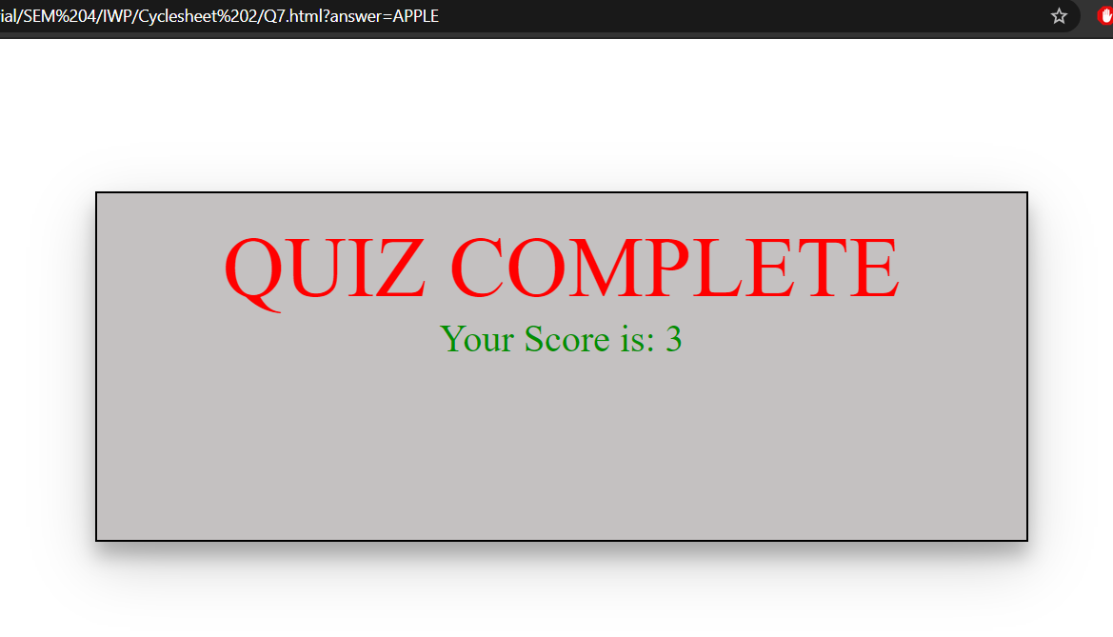

**Q8.**

**Code (HTML and JavaScript) –**

<!DOCTYPE html>

<html lang="en">

<head>

<meta charset="UTF-8">

<meta http-equiv="X-UA-Compatible" content="IE=edge">

<meta name="viewport" content="width=device-width, initial-scale=1.0">

<title>Q8</title>

<script>

var ano=[];

var limit=[];

var bbal=[];

var exp=[];

var pay=[];

var nbal=[];

var i=0;

function myfunction(){

var x=prompt("Account number","0");

var y=prompt("Balance at the beginning of the month","0");

var z=prompt("Total of all items charged this month","0");

var a=prompt("Total of all credits applied to the account this month","0");

var b=prompt("Allowed credit limit","0");

x=parseInt(x);

y=parseInt(y);

z=parseInt(z);

a=parseInt(a);

b=parseInt(b);

ano.push(x);

limit.push(b);

bbal.push(y);

exp.push(z);

pay.push(a);

nbal[i]=bbal[i]+exp[i]-pay[i];

document.getElementById("disp").innerHTML += "Account number: "+ano[i]+"<br>Beginning balance: "+bbal[i]+"<br>Credit limit: "+limit[i]+"<br>Total Expenditure: "+exp[i]+"<br>Total Credit Payments: "+pay[i]+"<br>New Balance: "+nbal[i];

if(nbal[i]>limit[i])

document.getElementById("disp").innerHTML += "<br>Credit Limit Exceeded<br><br>";

else

document.getElementById("disp").innerHTML += "<br><br>";

i++;

}

</script>

</head>

<body>

<span id="disp"></span>

<button onclick="myfunction()">Add new customer</button>

</body>

</html>

**Output –**

**Initially**

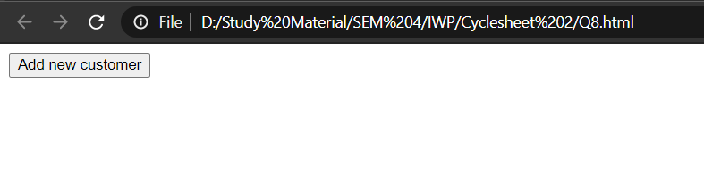

**Entering values**

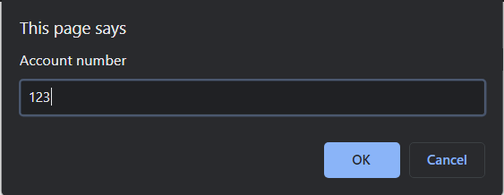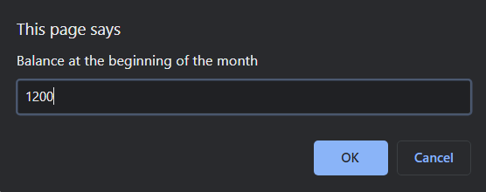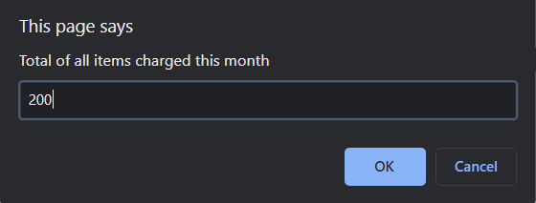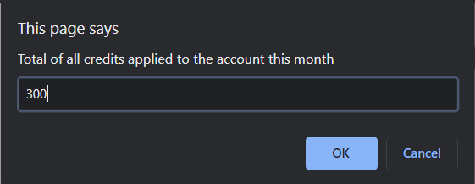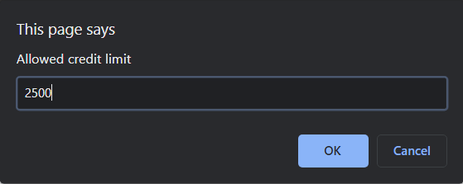

**After entering values**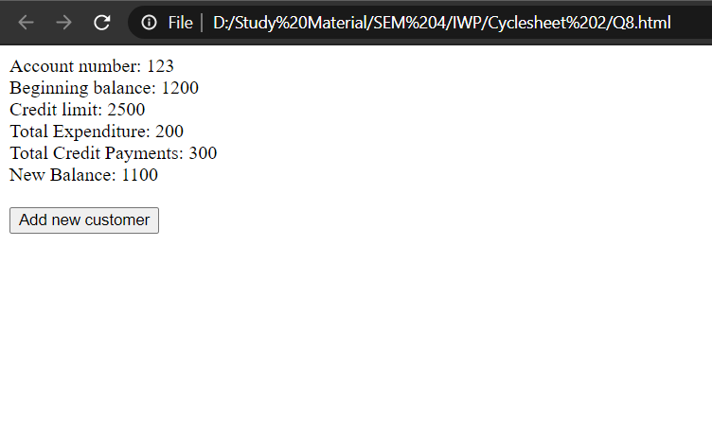

**After entering values of two more customers**

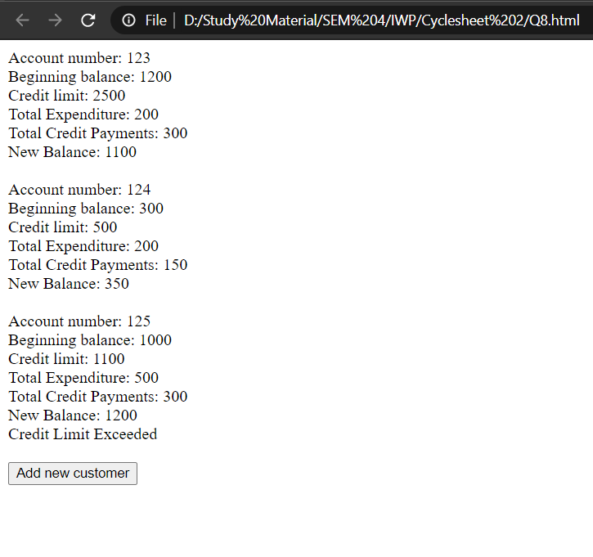

**Q9.**

**Code –**

**HTML**

<!DOCTYPE html>

<html lang="en">

<head>

<meta charset="UTF-8">

<meta http-equiv="X-UA-Compatible" content="IE=edge">

<meta name="viewport" content="width=device-width, initial-scale=1.0">

<title>Q9</title>

<link rel="stylesheet" href="Q9.css">

<script src="Q9.js"></script>

</head>

<body>

<div class="start" id="start">

<p class="squiz">QUIZ</p>

<hr>

<ul><h2>Rules</h2>

<li>The quiz is of the type <b>MCQ</b></li>

<li>Every question has only <b>ONE</b> correct answer</li>

<li>You cannot go back to the previous question</li>

<li>You have <b>30</b> seconds for each question</li>

<li>Number of questions are <b>5</b></li>

</ul>

<button class="button" onclick="start();">START</button>

</div>

<div class="box" id="box">

<span class="before">Time left: <span id="countdown"></span></span>

<p id="ques"></p>

<span>a.</span><input type="radio" id="a" name="quiz" value="a"><span>

<label for="a" id="la"></label></span><br>

<span>b.</span><input type="radio" id="b" name="quiz" value="b"><span>

<label for="b" id="lb"></label></span><br>

<span>c.</span><input type="radio" id="c" name="quiz" value="c"><span>

<label for="c" id="lc"></label></span><br>

<span>d.</span><input type="radio" id="d" name="quiz" value="d"><span>

<label for="d" id="ld"></label></span><br><br>

<button class="button" id="next" style="margin-left: 80%;" onclick="button_click();">Next</button>

</div>

</body>

</html>

**CSS**

body{

padding: 5px;

}

span{

height: 10px;

width: auto;

display: inline-block;

margin: 5px;

font-size: 18px;

}

.box{

border: solid rgb(172, 172, 172) 2px;

background-color: rgb(221, 221, 221);

margin: 100px auto;

width: 50%;

height: auto;

padding: 30px;

box-shadow: 0 12px 10px 0 rgba(0,0,0,0.24), 0 17px 25px 0 rgba(0,0,0,0.19);

display: none;

}

.start{

border: solid rgb(172, 172, 172) 2px;

background-color: rgb(221, 221, 221);

margin: 100px auto;

width: 50%;

padding: 30px;

box-shadow: 0 12px 10px 0 rgba(0,0,0,0.24), 0 17px 25px 0 rgba(0,0,0,0.19);

}

.squiz{

text-align: center;

font-size: 24px;

font-weight: bold;

}

li{

font-size: 18px;

margin-top: 4px;

}

.button{

font-size: 16px;

padding: 10px;

width: 100px;

background-color: rgb(155, 155, 155);

border-radius: 20px;

border: solid 2px;

margin: 0 auto;

display: block;

}

#ques{

font-size: 24px;

font-weight: bold;

margin-left: 7px;

margin-top: 50px;

}

.before{

position: relative;

float: right;

font-size: 24px;

}

#countdown{

font-size: 24px;

font-weight: bold;

display: inline-block;

}

.button:hover{

background-color: rgb(122, 122, 122);

}

.button:active{

background-color: rgb(100, 100, 100);

}

.button:focus{

outline: none;

}

**JavaScript**

var score = 0;

var i=0;

var c=0;

var ques = ["A figure with 3 sides is known as a?","The smallest two-digit number is?","A figure which has no sides and no corners is called?","When any number is multiplied by 0, the answer is always?","A figure with four equal sides is called?"];

var options = [

["Circle","Square","Triangle","Rectangle"],

["12","9","20","10"],

["Circle","Triangle","Hexagon","Square"],

["The number itself","Zero","Infinity","Cannot be determined"],

["Circle","Square","Rectangle","Triangle"]

];

var ans = ["c","d","a","b","b"]

function start(){

timer();

document.getElementById("start").style.display = "none";

document.getElementById("box").style.display = "block";

i=Math.floor(Math.random()*5);

document.getElementById("ques").innerHTML = ques[i];

document.getElementById("la").innerHTML = options[i][0];

document.getElementById("lb").innerHTML = options[i][1];

document.getElementById("lc").innerHTML = options[i][2];

document.getElementById("ld").innerHTML = options[i][3];

ques[i]=="done";

}

function button_click(){

timer();

if(c!=5)

{

c++;

ques[i] = "done";

if(document.getElementById("a").checked == true)

{

document.getElementById("a").checked = false;

var x = "a";

}

else if(document.getElementById("b").checked == true)

{

document.getElementById("b").checked = false;

var x = "b";

}

else if(document.getElementById("c").checked == true)

{

document.getElementById("c").checked = false;

var x = "c";

}

else if(document.getElementById("d").checked == true)

{

document.getElementById("d").checked = false;

var x = "d";

}

else

var x ="";

if(x == ans[i])

score++;

}

while(ques[i]=="done" && c!=5)

{

i=Math.floor(Math.random()*5);

}

if(c==4)

document.getElementById("next").innerHTML = "End quiz";

if(c!=5)

{

document.getElementById("ques").innerHTML = ques[i];

document.getElementById("la").innerHTML = options[i][0];

document.getElementById("lb").innerHTML = options[i][1];

document.getElementById("lc").innerHTML = options[i][2];

document.getElementById("ld").innerHTML = options[i][3];

}

else

{

var y = document.getElementsByTagName("span");

console.log(y);

var z = document.getElementsByTagName("input");

var t = document.getElementsByTagName("label");

for(var a=0;a<y.length;a++)

{

y[a].style.display="none";

}

for(var a=0;a<4;a++)

{

z[a].style.display="none";

t[a].style.display="none";

}

document.getElementById("next").style.display="none";

document.getElementById("ques").style.textAlign = "center";

document.getElementById("ques").innerHTML = "QUIZ COMPLETE<br><br>Your score is: "+score+"/5";

}

}

var p=0;

var countdown = 0;

function timer(){

p=29;

clearInterval(countdown);

countdown = setInterval(function()

{

document.getElementById("countdown").style.color = "black";

if(p<=5)

document.getElementById("countdown").style.color = "red";

if(p<1)

{

button_click();

}

document.getElementById("countdown").innerHTML = p;

p--;

},1000)

}

**Output –**

**Initially**

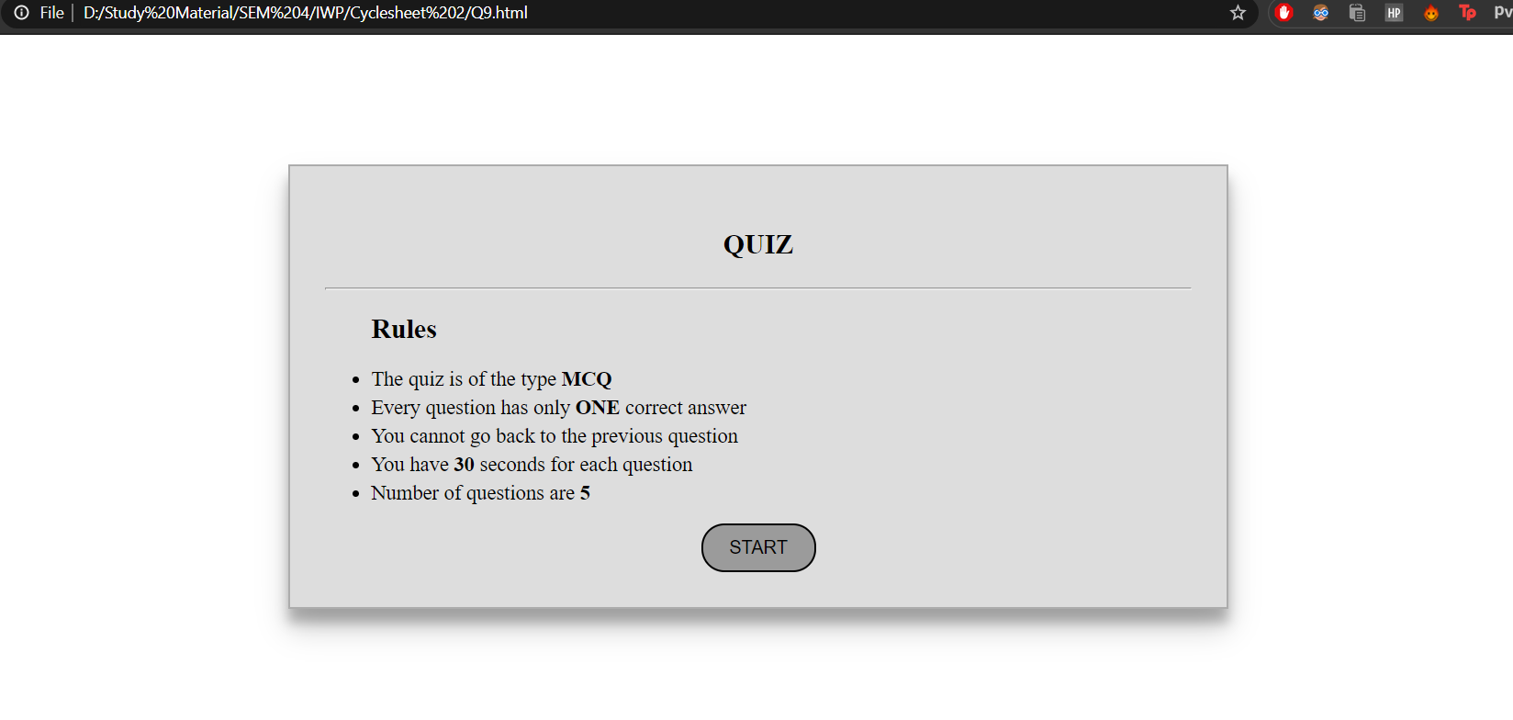

**Q1**

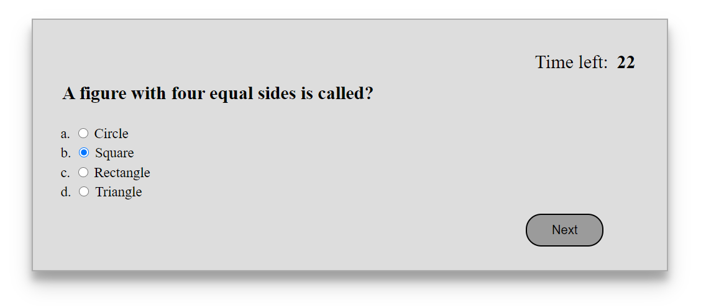

**Q2**

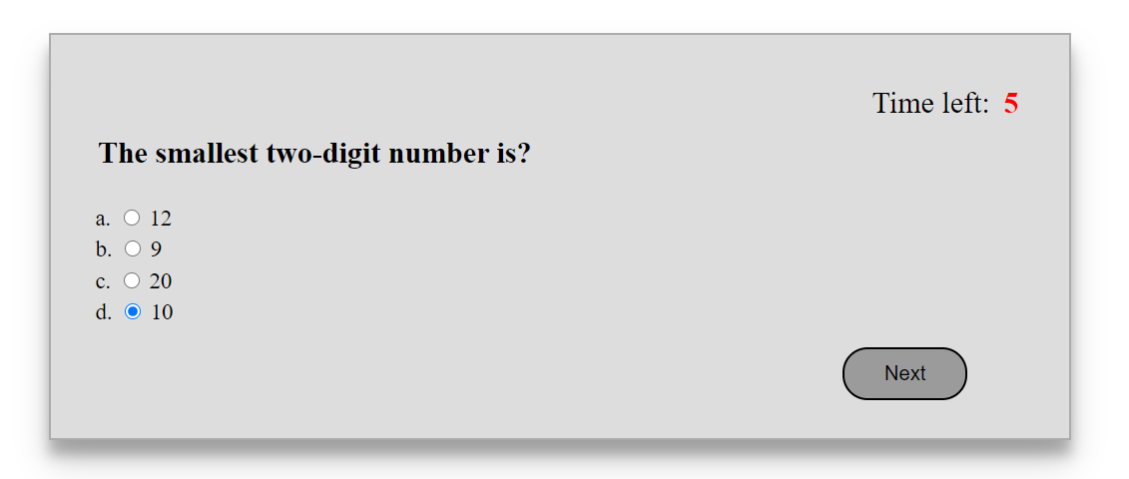

**Q3**

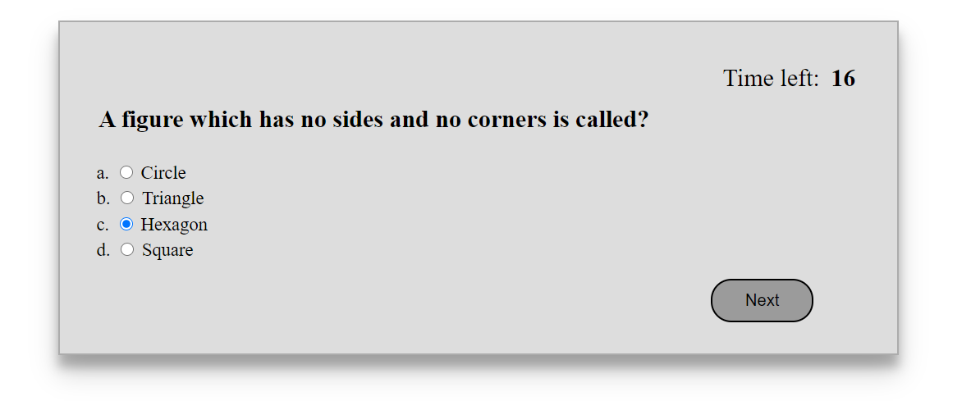

**Q4**

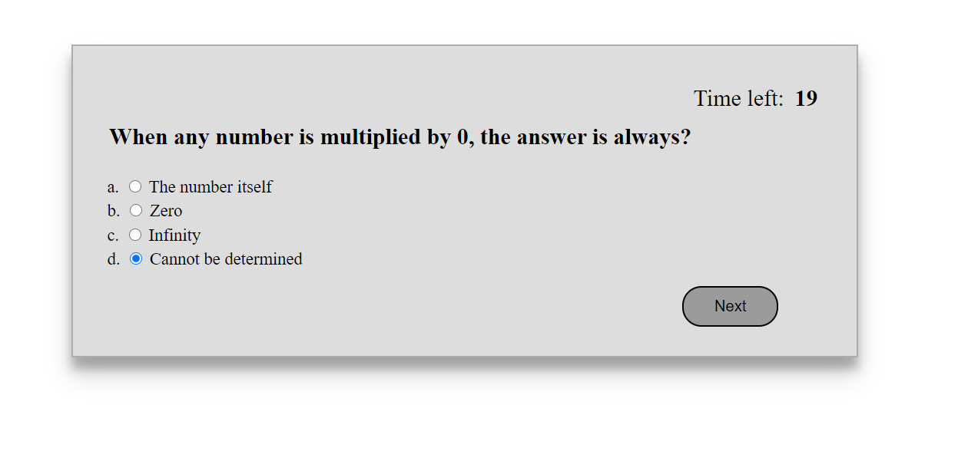

**Q5**

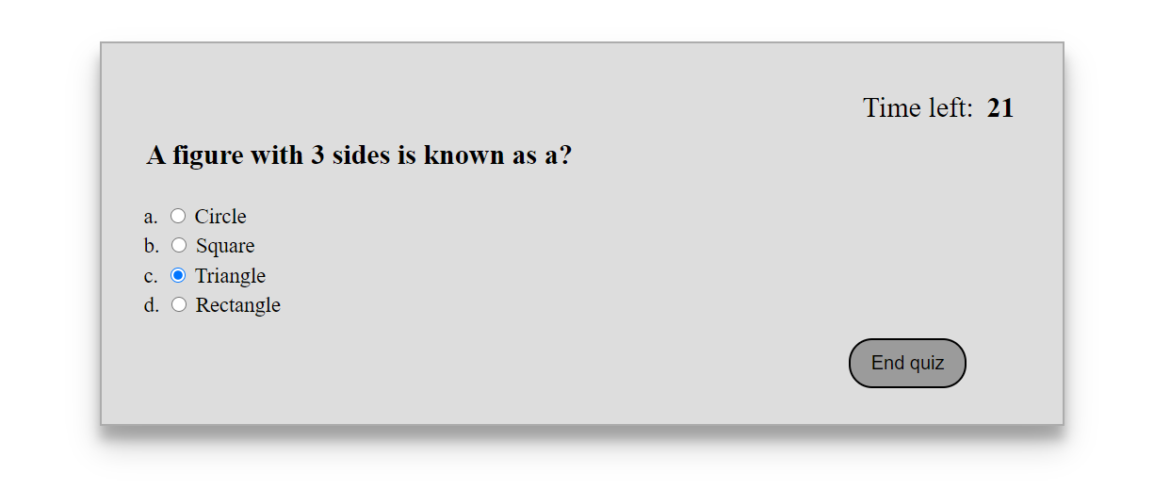

**Result**

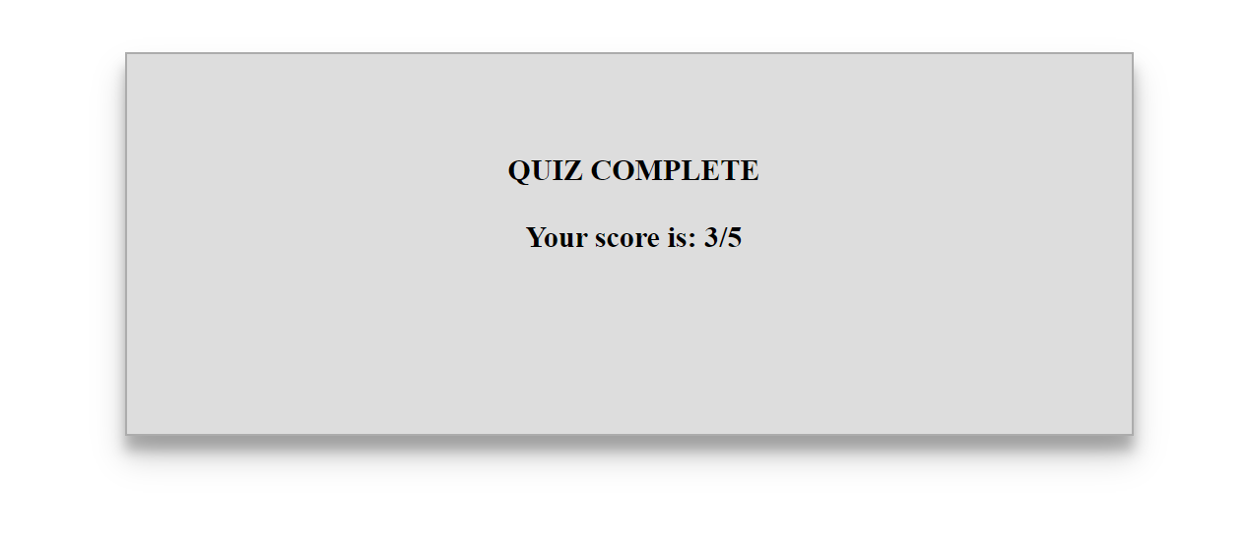

**Q10.**

**Code –**

**HTML**

<!DOCTYPE html>

<html lang="en">

<head>

<meta charset="UTF-8">

<meta http-equiv="X-UA-Compatible" content="IE=edge">

<meta name="viewport" content="width=device-width, initial-scale=1.0">

<title>Q10</title>

<script src="Q10.js"></script>

</head>

<body style="padding: 20px;">

<div style="border: black solid 1px; width: fit-content; padding: 10px;">

<h1>Validate Credit Cards</h1>

<form>

<label for="card">Credit Card: </label>

<select id="card" name="card">

<option value="American Express">American Express</option>

<option value="Diners Club">Diners Club</option>

<option value="Discover">Discover</option>

<option value="JCB">JCB</option>

<option value="MasterCard">MasterCard</option>

<option value="Visa">Visa</option>

</select><br>

<label for="number">Number: </label>

<input type="text" name="number" id="number"><br><br>

<button type="button" onclick="Validate();">Validate</button>

</form>

<p style="border: black solid 1px; display: none;" id="disp"></p>

</div>

</body>

</html>

**JavaScript**

function Validate(){

document.getElementById("disp").style.display = "block";

var x=document.getElementById("card").value;

var y =document.getElementById("number");

if(x == "American Express")

y.pattern = "^[34,37]{2}\\d{13}$";

else if(x == "Diners Club")

y.pattern = "(^[300-305]{3}\\d{11}$)|(^[36,38]{2}\\d{12}$)";

else if(x == "Discover")

y.pattern = "(^[6011]{4}\\d{12}$)|(^[65]{2}\\d{14}$)";

else if(x == "JCB")

y.pattern = "(^[2131,1800]{4}\\d{11}$)|(^[35]{2}\\d{14}$)";

else if(x == "MasterCard")

y.pattern = "^[51-55]{2}\\d{14}$";

else if(x == "Visa")

y.pattern = "(^[4]{1}\\d{12}$)|(^[4]{1}\\d{15}$)";

if(document.getElementById("number").validity.patternMismatch)

document.getElementById("disp").innerHTML = "Invalid Credit Card Number";

else

document.getElementById("disp").innerHTML = "Valid Credit Card Number";

}

**Output –**

**Initially**

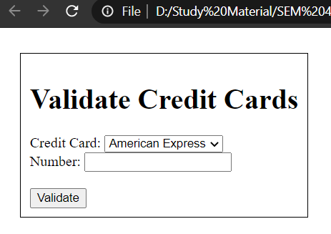

**American Express**

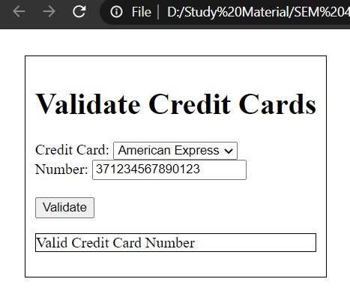

**Diners Club**

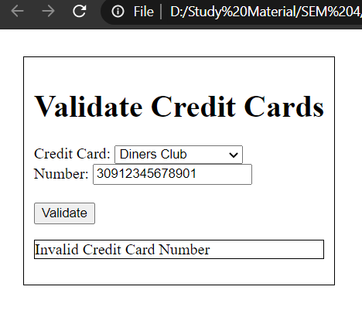

**Discover**

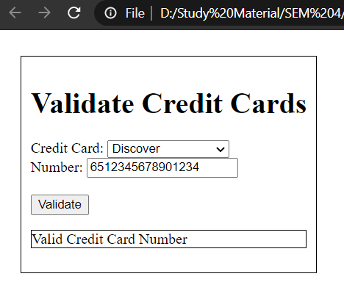

**JCB**

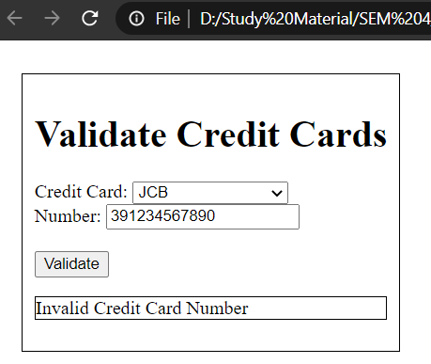

**MasterCard**

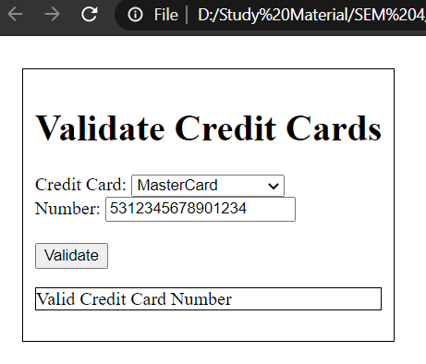

**Visa**

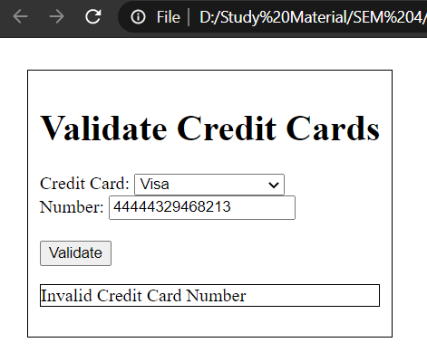

**Q11.**

**Code –**

**HTML**

<!DOCTYPE html>

<html lang="en">

<head>

<meta charset="UTF-8">

<meta http-equiv="X-UA-Compatible" content="IE=edge">

<meta name="viewport" content="width=device-width, initial-scale=1.0">

<title>Q11</title>

<script src="Q11.js"></script>

</head>

<body style="padding: 20px;">

<form>

<label for="username">Username: </label>

<input type="text" name="username" id="username" pattern="^[A-Z]\w+(\s[A-Z]{1}\.)+$"><br><br>

<label for="email">Email ID: </label>

<input type="email" name="email" id="email" pattern="\w+@\w+(\.[a-z]{2,})+$"><br><br>

<label for="mobile">Mobile No: </label>

<input type="text" name="mobile" id="mobile" pattern="^[9,8,7]{1}[0-9]{9}$"><br><br>

<label for="age">Age: </label>

<input type="number" name="age" id="age" min="18" max="60"><br><br>

<button type="button" onclick="ValidateForm();">Submit</button>

</form>

<p id="disp"></p>

</body>

</html>

**JavaScript**

function ValidateForm(){

if(document.getElementById("username").validity.patternMismatch)

{

document.getElementById("disp").innerHTML = "Invalid Form Data";

alert("Username does not follow the pattern 'Username X.'");

return false;

}

else if(document.getElementById("email").validity.patternMismatch)

{

document.getElementById("disp").innerHTML = "Invalid Form Data";

alert("Invalid Email Format");

return false;

}

else if(document.getElementById("mobile").validity.patternMismatch)

{

document.getElementById("disp").innerHTML = "Invalid Form Data";

alert("Invalid mobile no format");

return false;

}

else if(document.getElementById("age").validity.rangeOverflow || document.getElementById("age").validity.rangeUnderflow)

{

document.getElementById("disp").innerHTML = "Invalid Form Data";

alert("Age not between 18 and 60");

return false;

}

else

{

document.getElementById("disp").innerHTML = "Valid Form Data";

return true;

}

}

**Outputs –**

